## Bathymetry Notes

#### Updated 6/16/15

GSLM_Volume_Calcs_20110915_noProposedPonds.xlsx contains area volume data from Biowest with proposed GSLM ponds excluded as that information was proprietary.

GSLM_Bathymetry_noProposedPonds.csv is the RTab exported for easy import to R

Areas used in Biowest Bathymetry Calculations are defined in the following two figures

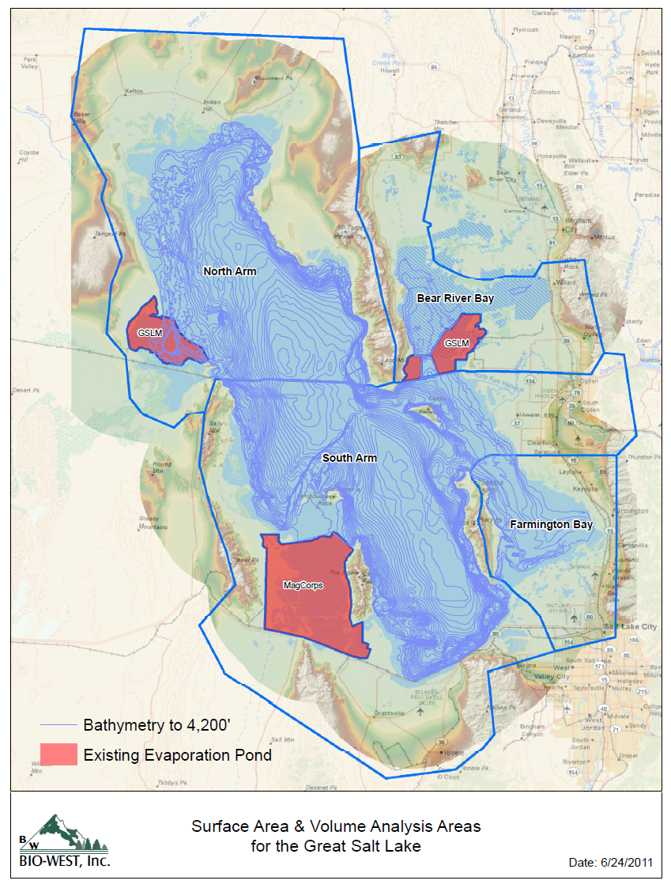

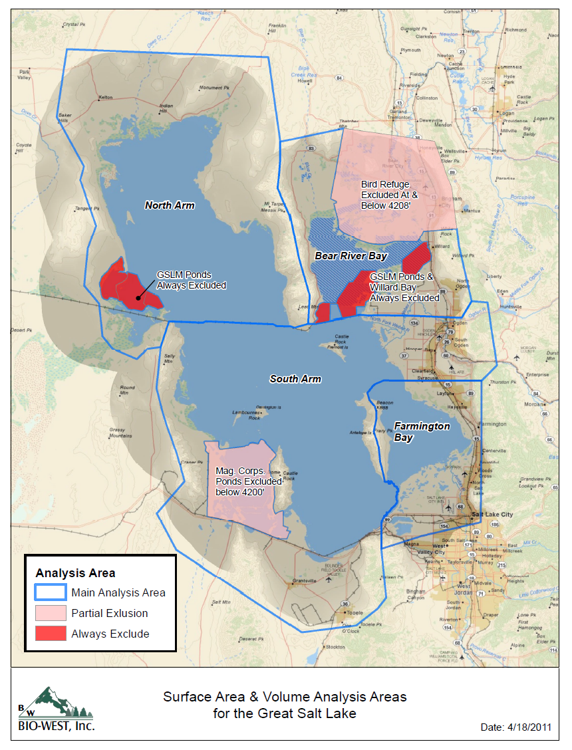

In interpreting this data the assumption is that data in RTab and csv file is non overlapping.

Codings for ponds used

|  |  |  |
| --- | --- | --- |
| Code | Name | Notes |
| brb | Bear River Bay | Part of S arm |
| brbpond | Existing GSLM Pond in Bear River Bay | Constructed 1967. For this analysis excluded from lake for all times. There is uncertainty here as to whether this includes both ponds illustrated above and Willard Spur. The assumption is that it does. |
| brmbr | Bear River Migratory Bird Refuge | Part of S arm |
| farmb | Farmington Bay | Part of S arm |
| south | Main body of S arm (Gilbert Bay) | Part of S arm |
| mag | Magnesium Corp Ponds in S Arm | Part of S arm prior to construction and when dike was breached |
| north | Main body of north arm (Gunnison bay) | Part of N Arm |
| northpond | Existing GSLM north ponds | Constructed 1993. Taken as part of N arm for historic analysis. Excluded in Scenarios |

R commands to set up bathymetry

In GSL Analysis.R

####### Read Level Area & Volume tables

bathtab=read.csv("Bathymetry/GSLM_Bathymetry_noProposedPonds.csv")

arean=bathtab$northa+bathtab$northponda

voln=bathtab$northv+bathtab$northpondv

areas=bathtab$southa+bathtab$brba+bathtab$farmba+bathtab$brmbra

vols=bathtab$southv+bathtab$brbv+bathtab$farmbv+bathtab$brmbrv

LAVN=data.frame(level=bathtab$Level*0.3048,area=arean*4047,vol=voln*1233.5256)

LAVS=data.frame(level=bathtab$Level*0.3048,area=areas*4047,vol=vols*1233.5256)

LAVC=data.frame(level=bathtab$Level*0.3048,area=(arean+areas)*4047,vol=(voln+vols)*1233.5256) # Combined Bathymetry

LAVMAG=LAVS # S Arm with MagCorp ponds

LAVMAG$area=LAVS$area+bathtab$maga*4047

LAVMAG$vol=LAVS$vol+bathtab$magv*1233.5256

Pond Construction dates from Blaise Chanson, Biowest 8/25/11

|  |  |  |
| --- | --- | --- |
| **GSL Pond Construction** | |  |
|  |  |  |
| **East Ponds - Bear River Bay** | |  |
|  | Year Constructed | Acres |
| Main Body of Ponds | 1967 | 10,289 |
| Pond 26 | 1972 | 1,800 |
| Ponds 96, 97 & 98 | 1977 | 3,555 |
| Ponds 1/1A | 1983 | 3,616 |
| Pond 1B | 2004 | 2,740 |
|  |  |  |
|  |  |  |
| **West Ponds - Clyman Bay** | |  |
|  | Year Constructed | Acres |
| Ponds 112, 113 & 114 | 1993 | 25,383 |

From Loving et al 2000

Magcorp pond dike page 18 breached June 1986 and repaired January 1994

Gwynn 2011 presentation indicates that Magcorp started operations in 1972.

Tripp 2009 <http://digitalcommons.usu.edu/cgi/viewcontent.cgi?article=1308&context=nrei&sei-redir=1#search=%22great%20salt%20lake%20magnesium%20corporation%20dike%22> indicates that construction began in 1970